# Lab 3 Cloud Infrastructure Management Date: 12/01/2024

Carry out an experiment to create Virtual Box and run python/C program on Windows or Linux Platform using this .

**Step1: Create VirtualBox :**

**To download VirtualBox, go to the official site**[**virtualbox.org**](https://www.virtualbox.org/wiki/Downloads)**and download the latest version for windows.**

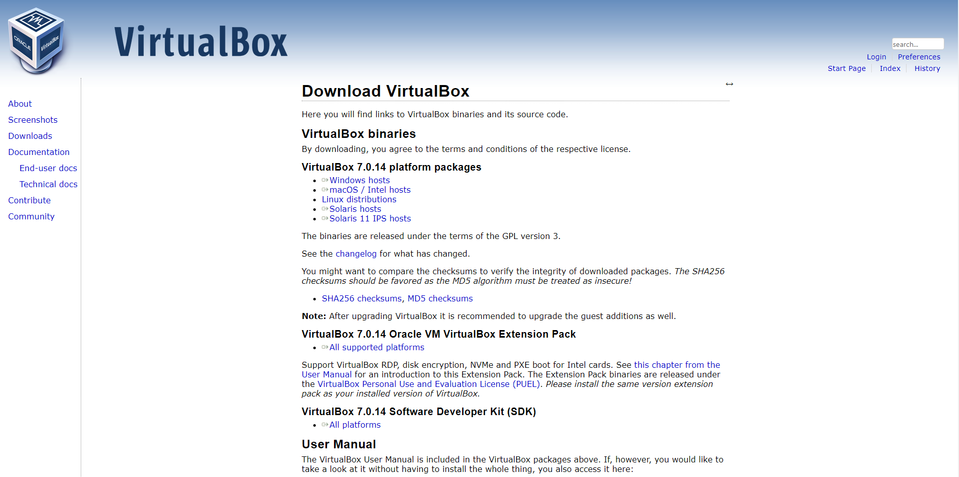

**Beginning with the Installation:**

* **Getting Started:**

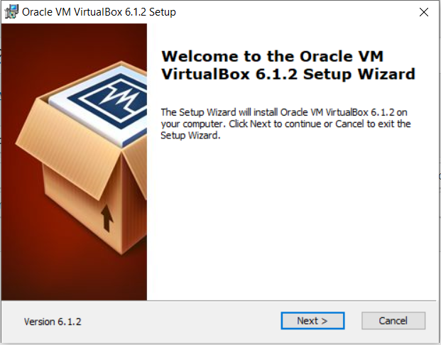

* **Select Installation Location:**

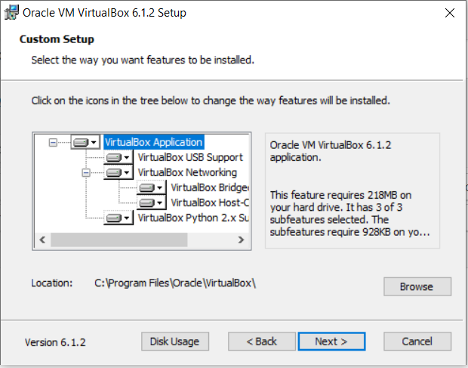

* **Creating Entries and Shortcuts:**

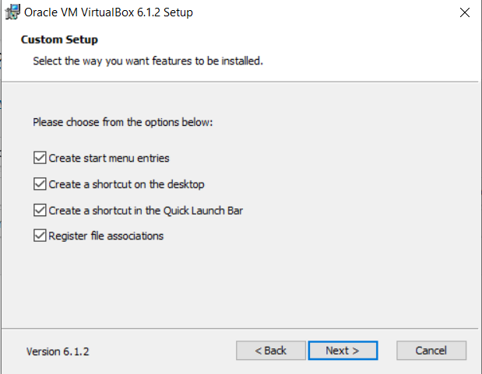

* **Ready to Install:**

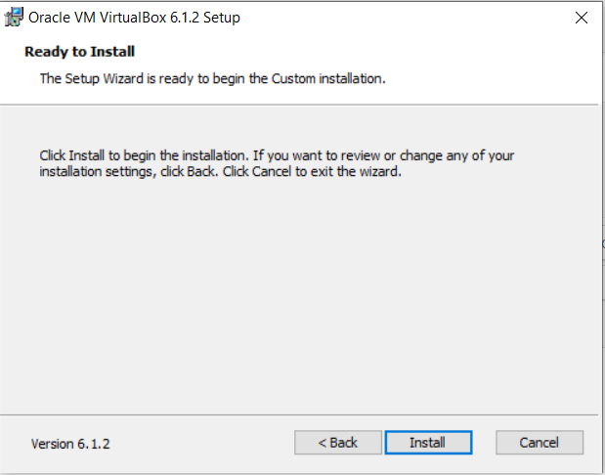

* **Installing Files and packages:**

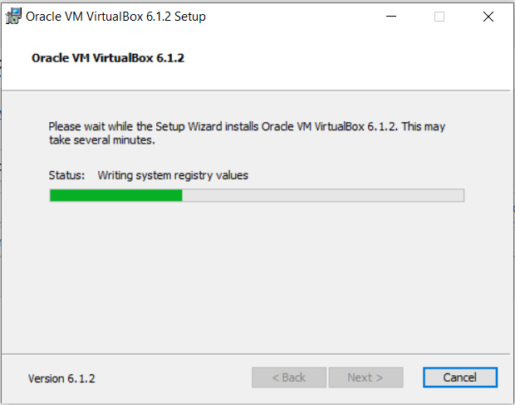

* **Installing Certificates:**

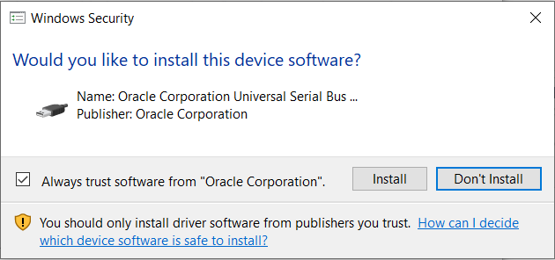

* **Finished Installation:**

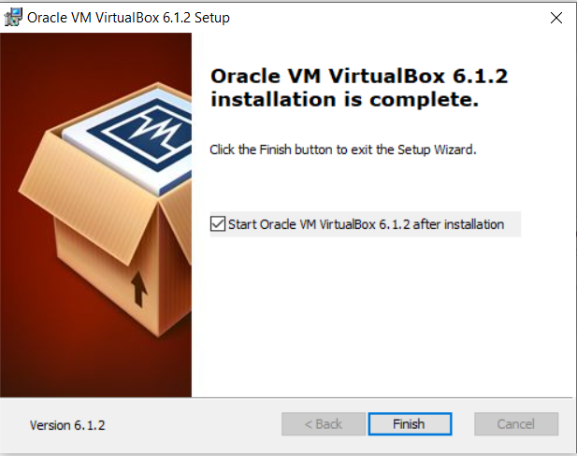

* **When you will open virtualbox it will look like as shown below:**

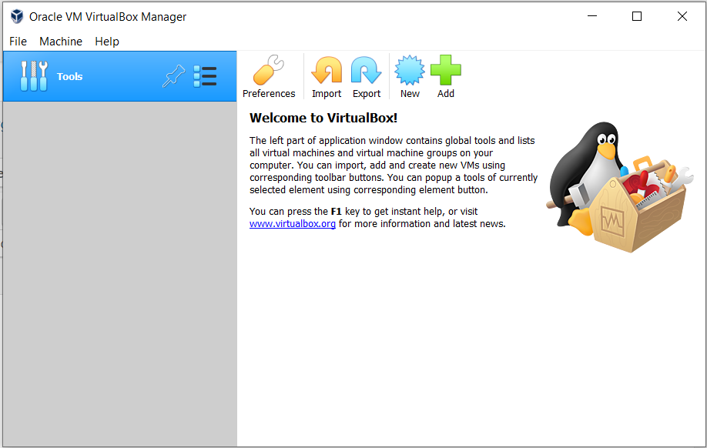

**Step2: Install Windows/Linux in it :**

* **Download Ubuntu ISO file**

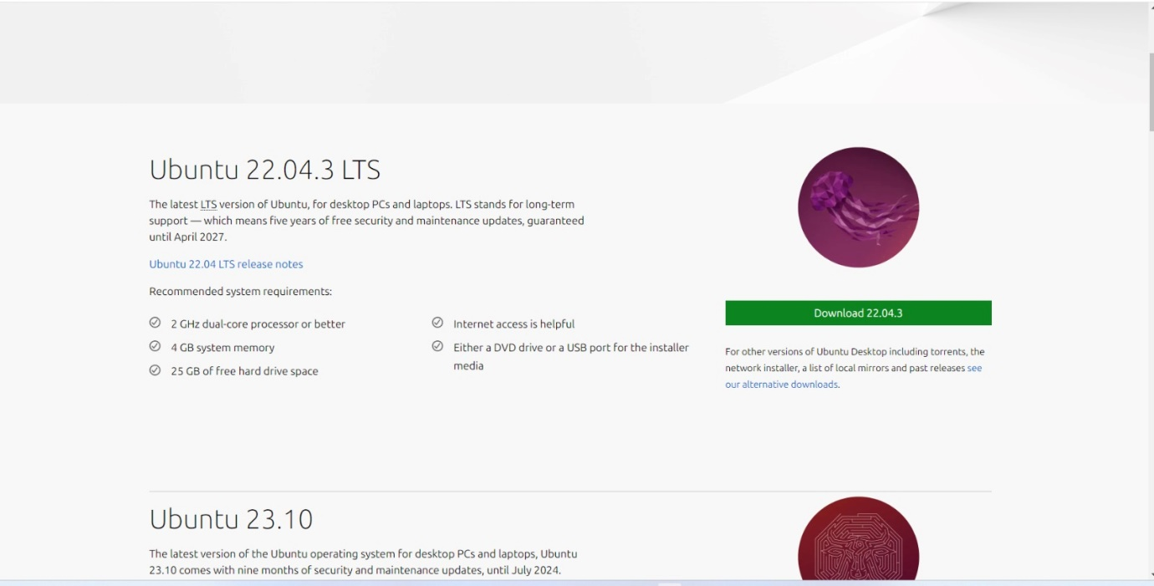

* **Give a Name to your Virtual Machine and select the Location for it to install.**

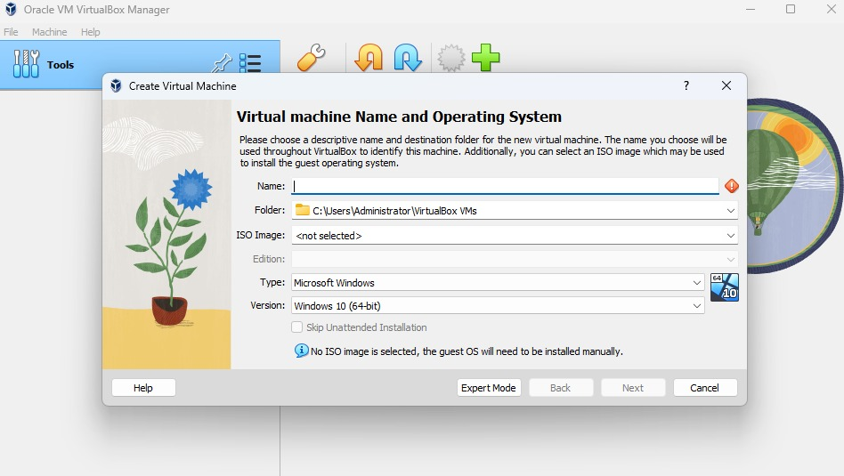

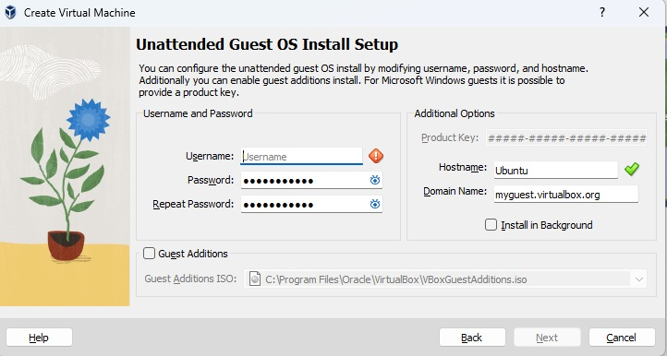

* **Assign RAM Size to your Virtual Machine.**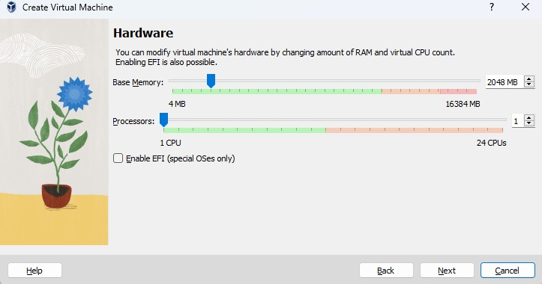
* **Create a Virtual Hard Disk for the machine to store files.**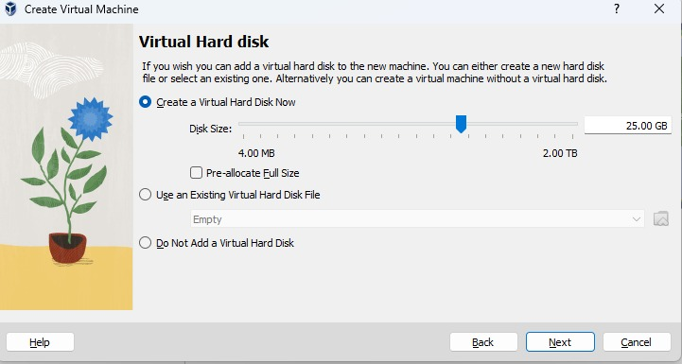

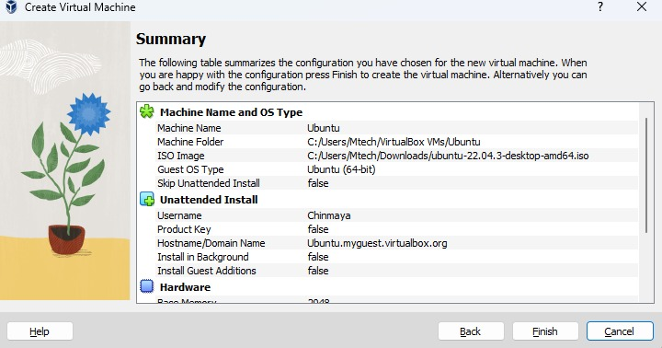

* **Proceed with the installation file and wait for further options.**

**Step3:Run a C/Python program in this platform:**

* **write a C code using text editor and run it.**

